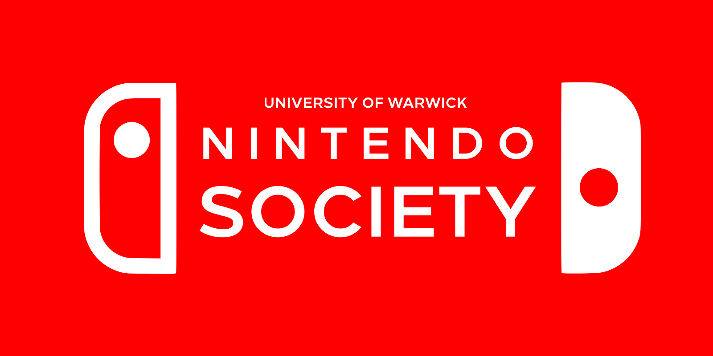

## **Open your eyes… It's Nintendo Society News Time!**

Onwards to the final week of term 2! And we have quite a few things planned for you all this week:

### **Smashton 3: Rage Factor**

### **Saturday 18/3, Geek Retreat Birmingham, 9:30am-9pm**

A few of us have registered to enter Smashton 3, a monthly Smash Wii U tournament held in Birmingham. Those interested, have a look at the event details here:

<https://www.facebook.com/events/905228962912782/>

<https://smash.gg/tournament/smashton-3-rage-factor>

If you are interested in competing, then sign up with a smash.gg account (its free) and register for Wii U Singles and/or Doubles by **Wednesday 15/3** (hence why I’m placing this at the top)! If you are just interested in spectating and cheering us on, you can show up on the day but you will still need to pay for the venue fee. Either case let one of the exec know so we can plan out travel arrangements!

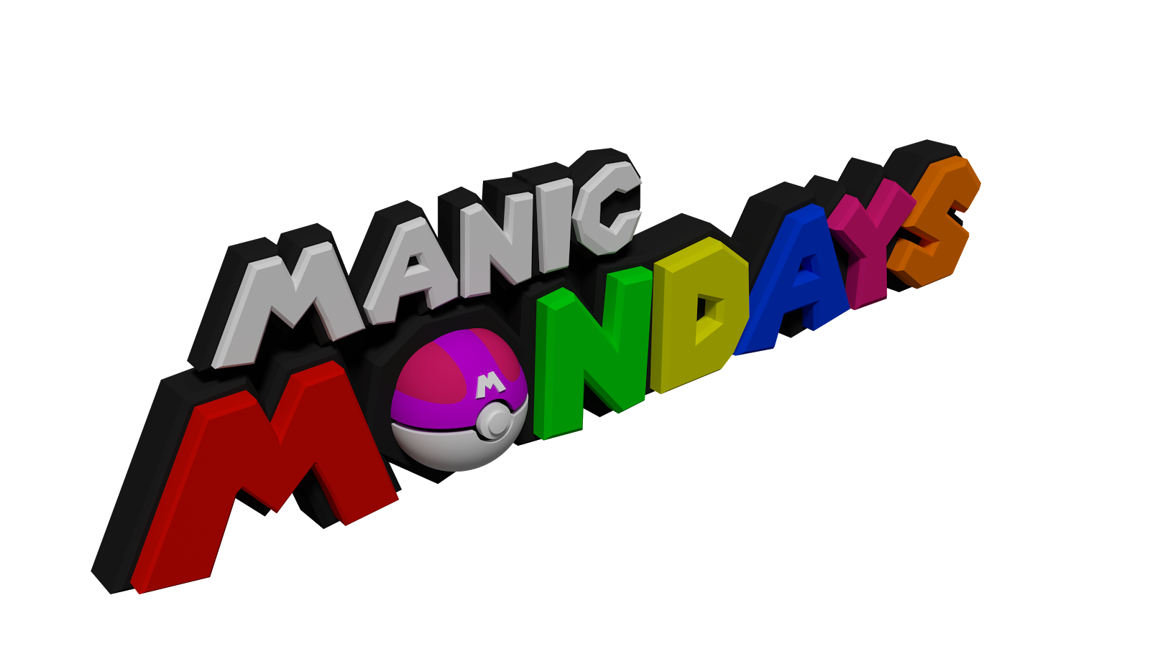

### **Manic Mondays**

### **Monday 13/3, R0.03/4, 6-10pm**

Come back for Monday madness! Again Nintendo Switch will be available to play so come experience the console if you haven’t already. Wii U has not been forgotten and still plays a major part in our events, so come for some fun local multiplayer action!



### **Smash Wednesday x Nintendo Society Championships**

### **Wednesday 15/3, R0.03/4, 2-10pm**

Our weekly Smash event returns with Melee and Wii U! However this week we shall be holding our 5th installment of the Nintendo Society Championships starting from ~5pm. This is a series of Nintendo themed challenges spanned across multiple consoles. The aim is to gather the most points to advance into the knockout rounds!

### **Smashton 3 Practice**

### **Thursday 16/3, R3.41, 6-10pm**

### **Friday 17/3, OC1.03, 4-10pm**

These are extra Smash Wii U sessions to help prepare those going to Smashton 3! These will mainly be focussed on competitive play, but even those not going to Smashton are welcome to come along to practice. We plan on holding tournament brackets on both days to best prepare people!

---------------------------------------------------------------------------------------

Well then, folks, until next time, staaaay fresh!

And Happy Gaming! :D

Timothy Sit

Nintendo Society Incoming President

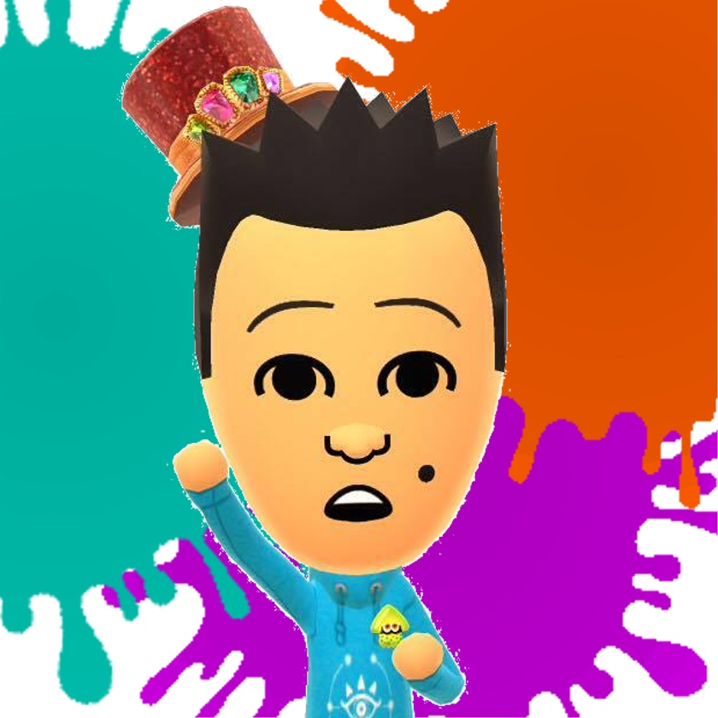

---------------------------------------------------------------------------------------

### **Find us on Social Media:**

Join our Facebook group:<https://www.facebook.com/groups/warwicknintendo/>

Follow us on Twitter:<https://twitter.com/warwicknintendo>

Join our Discord Chat:<https://discordapp.com/invite/Rf6QyfG>

Subscribe to our YouTube:<https://www.youtube.com/channel/UCzO_bZNfQDCAQa_zkEUgGVg>